# Notes on SharePoint Install and Configuration

## Remember to use a SQL Server Alias

https://technet.microsoft.com/en-us/library/ff607733.aspx#proc4

Can avoid a lot of headaches if SQL Server is moved to a different machine.

### Appendix

#### How to create SQL Alias for SharePoint

Follow the steps below to create a SQL Alias on all your SharePoint Servers:

TechNet Reference: <http://technet.microsoft.com/en-us/library/ff607733.aspx#clientalias>

1. Perform this on the Application Server that is hosting Central Administration

a. Stop all SharePoint Services

b. Open CLICONFIG.exe from C:\Windows\System32\cliconfg.exe (64 bit version of cliconfig.exe)

c. Enable TCP/IP under general tab   
[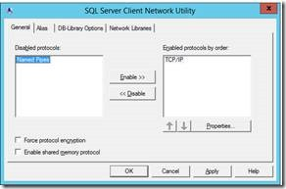](https://msdnshared.blob.core.windows.net/media/TNBlogsFS/prod.evol.blogs.technet.com/CommunityServer.Blogs.Components.WeblogFiles/00/00/00/86/44/metablogapi/4331.clip_image045_6C2F865C.jpg)

d. Click on Alias Tab

e. Type Current SQL Server Name in the Alias Name field

f. Type Current SQL Server Name in the Server field (see screenshot below. In your case SQL Alias and SQL Server name is the same)   
[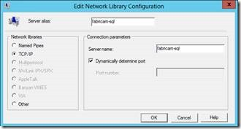](https://msdnshared.blob.core.windows.net/media/TNBlogsFS/prod.evol.blogs.technet.com/CommunityServer.Blogs.Components.WeblogFiles/00/00/00/86/44/metablogapi/6835.clip_image047_79959962.jpg)

g. Validate SQL Alias

i. Create a new text file on SharePoint Server and name it “TestDBConnection.udl”

ii. Double click to open the file and enter your SQL Server Alias name

iii. Use Windows Integrated Security

iv. You should be able to see all your SharePoint databases when you click on “Select the database on the Server”

h. Start all services for SharePoint Server / Reboot SharePoint Server

i. Perform the steps above on all other SharePoint servers